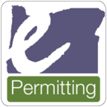**Help Desk Email:**[Oregon.ePermitting@Oregon.gov](mailto:Oregon.ePermitting@Oregon.gov)

**Help Desk Phone:**503-373-7396 (located in Salem)   
1-800-442-7457

# How to purchase an online permit through ePermitting as a homeowner

Visit [BuildingPermits.Oregon.gov](http://www.BuildingPermits.Oregon.gov)

** Note: if you have already registered for an account, skip to page 5 of this document.

Step 1 - Register and create an account.

This is required to apply for permits online.

How to register

1. Click on the **“Register Now”** button or at the top of the website.

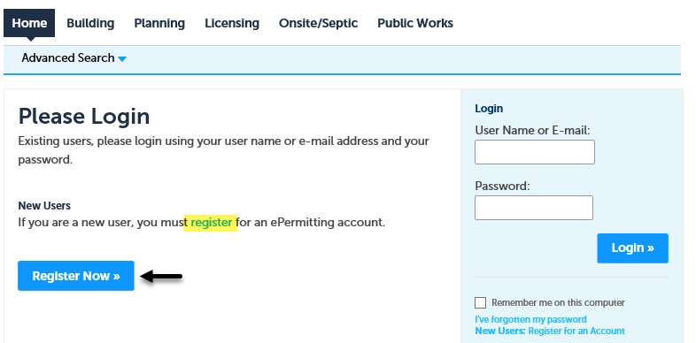



1. Read and agree to the terms and conditions by clicking the checkbox, then click on the **“Continue Registration”** button.

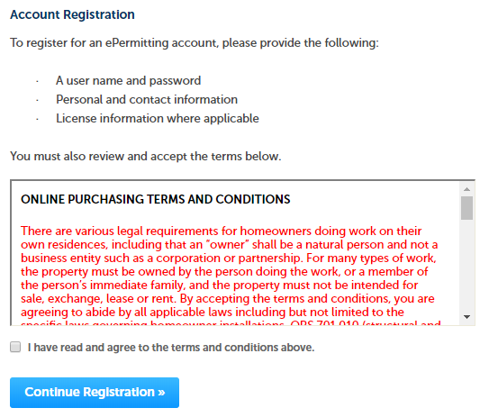

1. Enter your account information, then under Billing Information click the “**Add New**” button. **Note:** the red asterisks indicate required fields. If you are unsure what to enter into a field, click on the question mark field for more information.  
     
   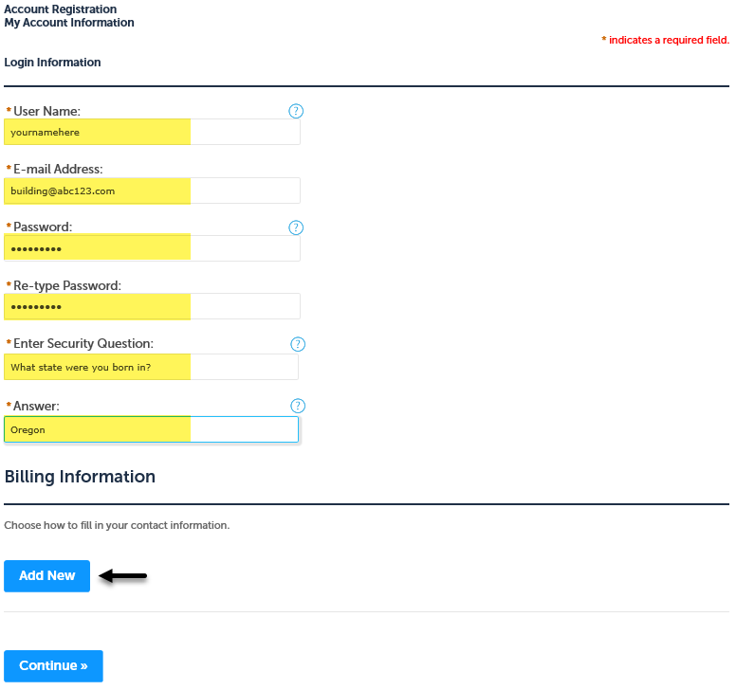
2. Next select contact type of Owner and click **“Continue”** button.

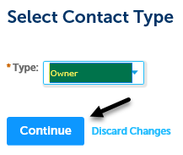

1. Enter all of the billing/permit contact information you want to have associated to the account, then click the **“Continue”** button. **Note:** adding your email to your account is very important for communicating throughout the process with the local jurisdiction, although not required.

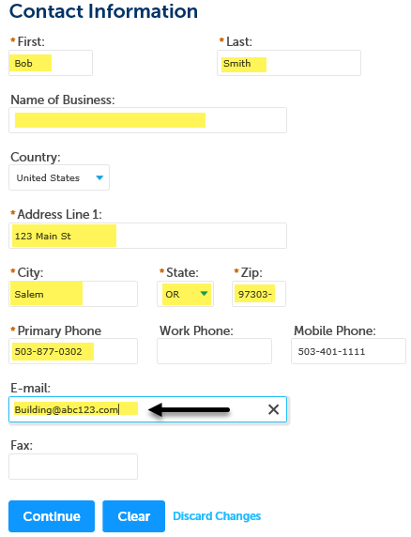

1. Review the information you entered, make any changes needed, then click the **“Continue”** button.

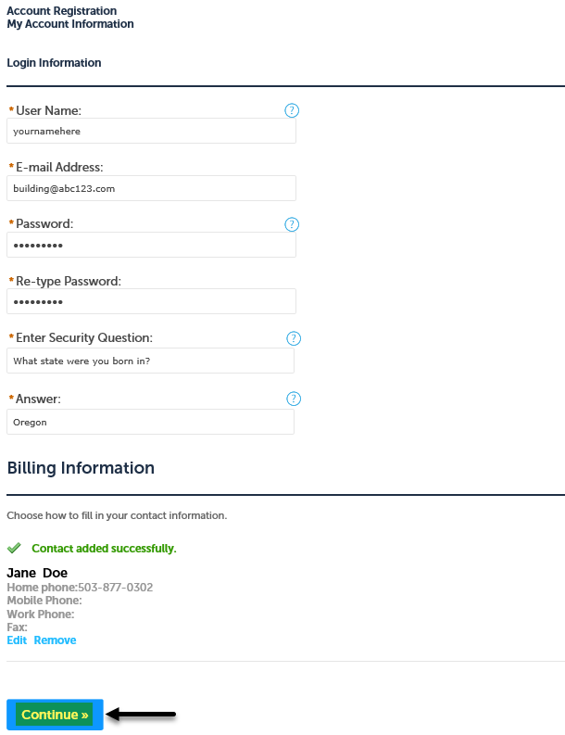

1. Now you are registered!

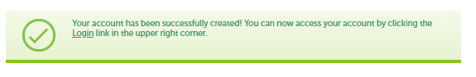

Next, to apply for permits, you need to add the **Homeowner “license(s)”** to your account, see next section for details.

How to add licenses to your registered account

1. Log into your account, enter your User Name or E-mail and Password, then click the **“Login”** button.

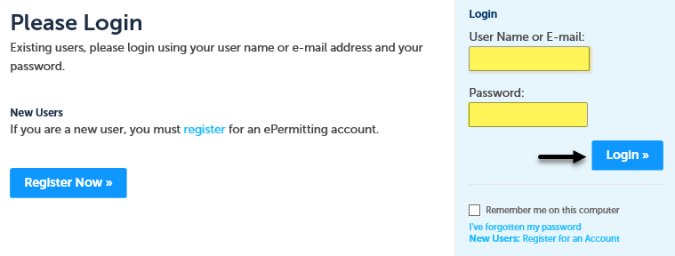

1. Click on **“Account Management”:**

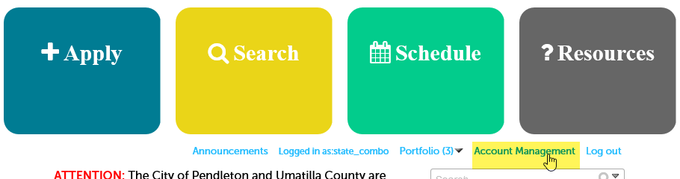

1. Click **“Add a License,”** then scroll midway down the web page to the License Information section.

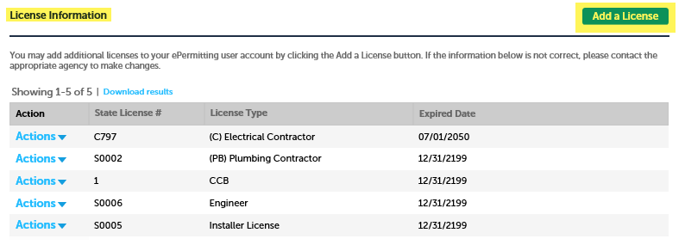

1. Select **“License Type”** from the dropdown menu, enter license number, and click “Find License”. See instructions below.  
     
   There are three homeowner licenses available to attach to your registered account – enter them exactly as shown.
   1. CCB for structural and mechanical work

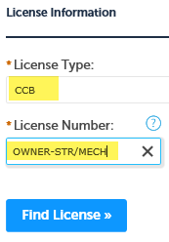

* 1. (C) Electrical Contractor for electrical work

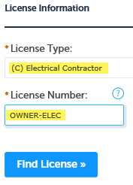

* 1. (PB) Plumbing Contractor for plumbing work

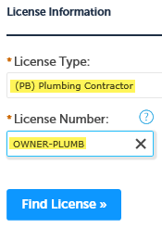

1. Click on **“Connect”** to attach the applicable license to your account:

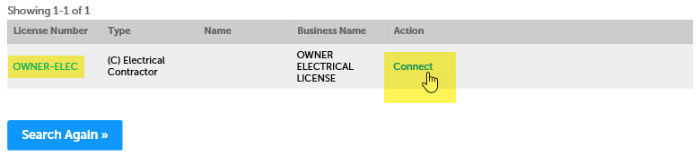

1. Click **“OK”** in the pop-up box, Message from webpage. **Note:** You will only have to attach these license(s) one time to your registered account for ongoing use.

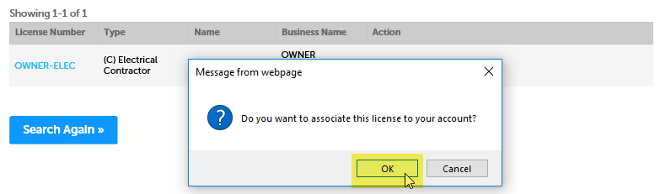

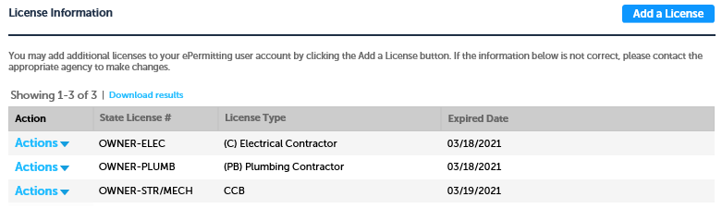

Now you have added a license to your account!  
You can add additional homeowner licenses by repeating the **Add a License** process.

# How to search for an address to apply for a permit

1. First, make sure you are logged in to your registered account in order to apply for a permit. Once logged in, hover your mouse over the large blue Apply box across the top of the website, then click on, **“Building Dept Application.”**

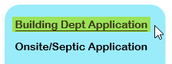

1. Read and agree to the terms and conditions by clicking the checkbox, then click on the **“Continue Application**” button.

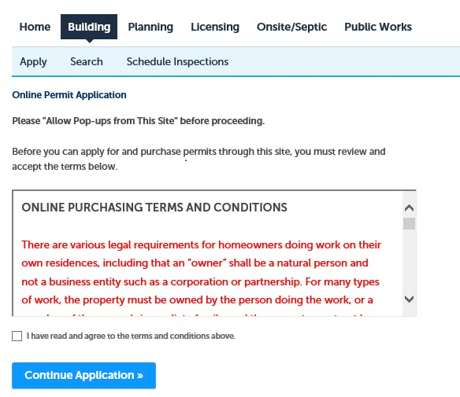

1. Enter the Work Site Location. For best results enter information into ONLY the two fields highlighted in green below, **Street No.** (number) and the first three characters of the **Street Name**, leaving all the other fields blank, then click on the **“Search”** button. **Note:** if you are not able to find the address or if the address is new please contact the building department for where you are pulling the permit (issuing jurisdiction) - for contact information visit the [Local building department directory](https://www.oregon.gov/bcd/lbdd/Pages/index.aspx).

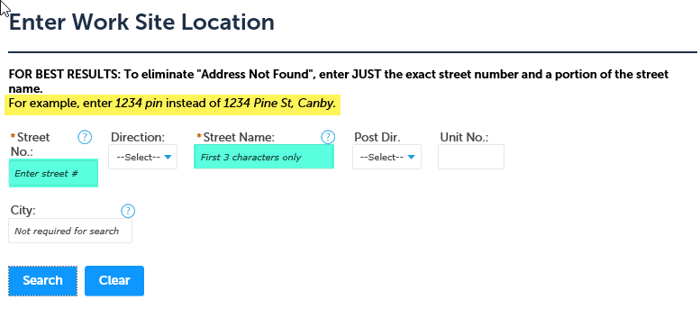

1. Verify that the address you searched for is now displayed, if there are multiple addresses, click the “Select” link next to the address you want to use for your application, then click on the issuing jurisdiction name, and finally click in the checkbox to select the type of permit you are wanting to pull. **Note:** if you need to apply for multiple permit types you MUST apply for each one separately. - **only select one item from the list.**

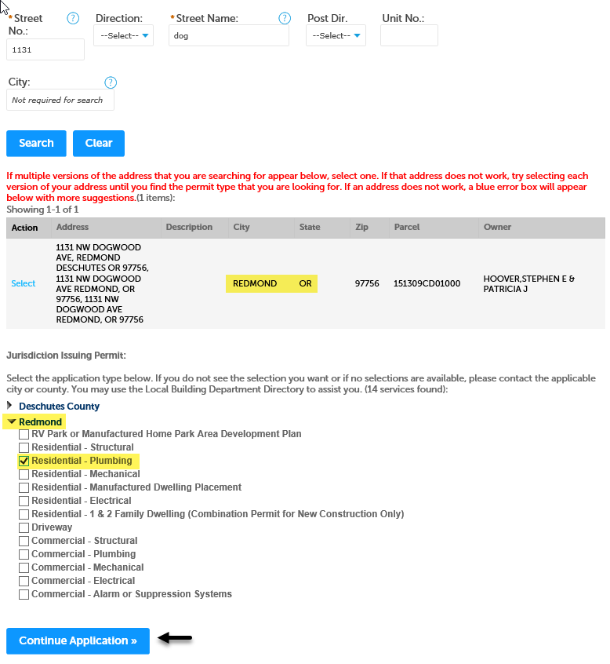

Once, you begin your application, if you any have questions about which services or fixtures you need to select for your project, or what documents you need to upload as attachments, please contact the building department for where you are pulling your permit.